Miah Shop Fashion Brand: Website Usability Report

1. Introduction
This report evaluates the user experience and product offerings of Miah Shop’s website. The goal is to analyze usability, design, and overall shopping experience.

2. First Impression (Homepage)

Good:

The homepage video is attractive and engaging. 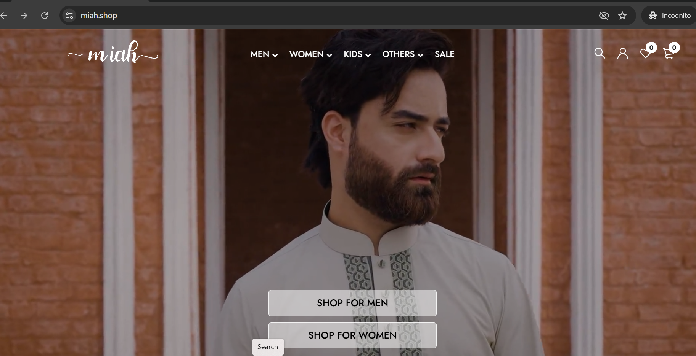
Figure-1: Homepage view

The images are visually appealing.

Needs Improvement:

The video may take time to load on slow internet.

Some users may find the homepage slightly content-heavy.

3. Navigation & Usability
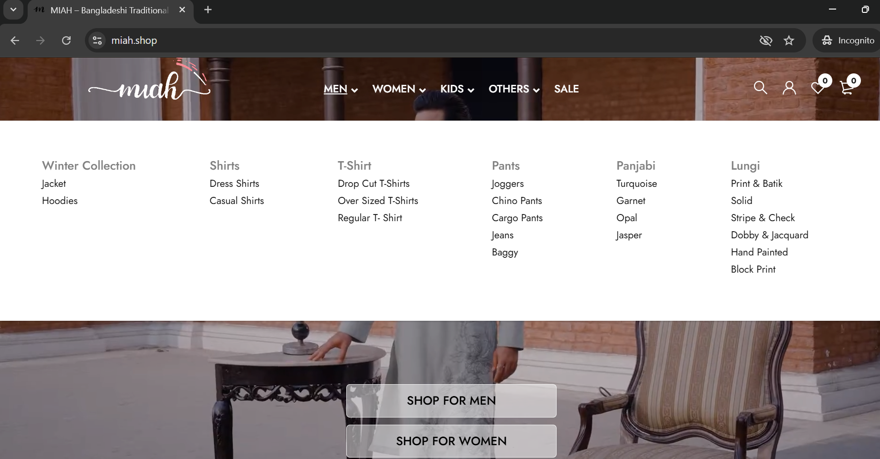

Figure-2: Menu view

Good
- The navigation bar is easy to find and clearly visible.
- Main categories such as Men’s and Women’s sections are accessible from the menu.
- The website structure allows users to reach product pages without much difficulty.
- Adequate spacing is present between elements, which helps overall layout readability.

Needs Improvement
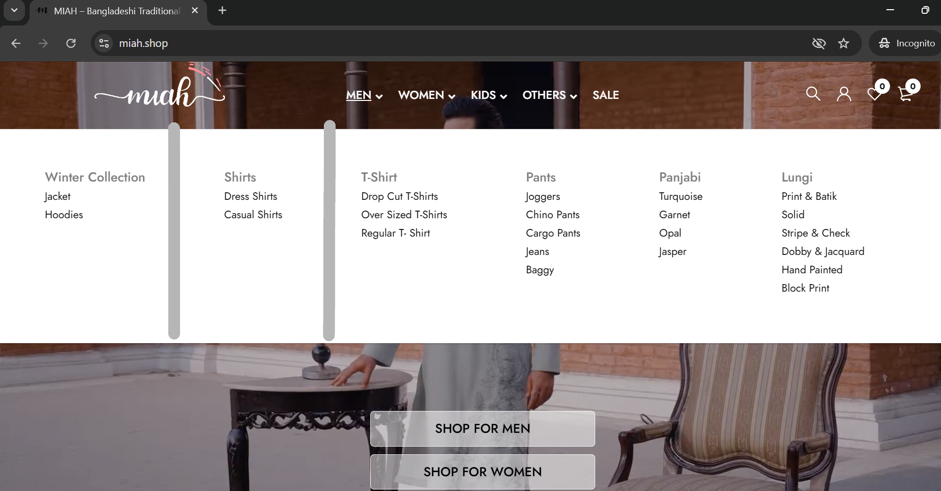

Figure-3: Menu view Improvement Suggestion
- The Men’s product section feels slightly text-heavy, making it harder to scan quickly.
- Content sections are not clearly separated, which reduces visual clarity.
- Adding horizontal lines or visual dividers would improve structure and readability.
- Including category-related images (e.g., men wearing the brand’s clothing) would enhance visual appeal and engagement.

4. Product Pages Review
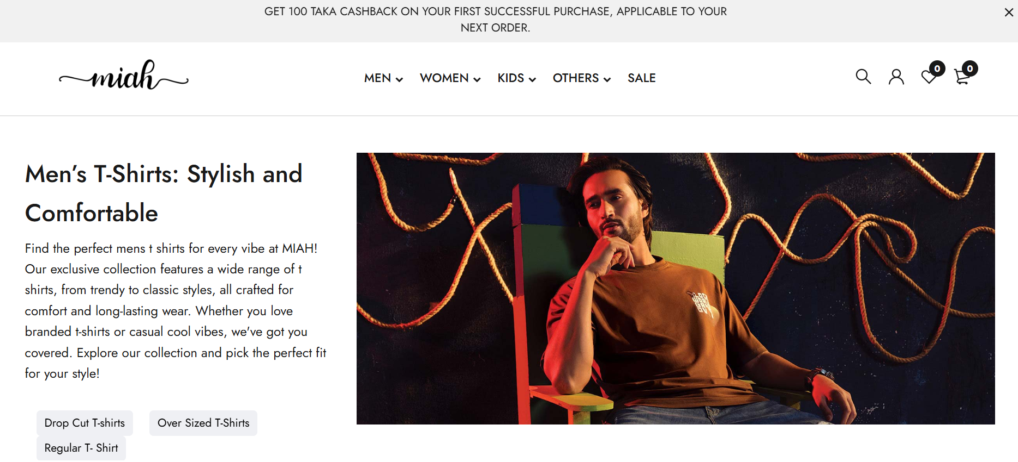

Figure-4: Product page view (Men)

🔹 Image Quality

Product images are present (e.g., “alt image”), but not clearly highlighted.

Lack of detailed visual presentation reduces product appeal.

No product zooming options.

High-quality, zoomable images from different angles would improve user understanding of design and fabric.
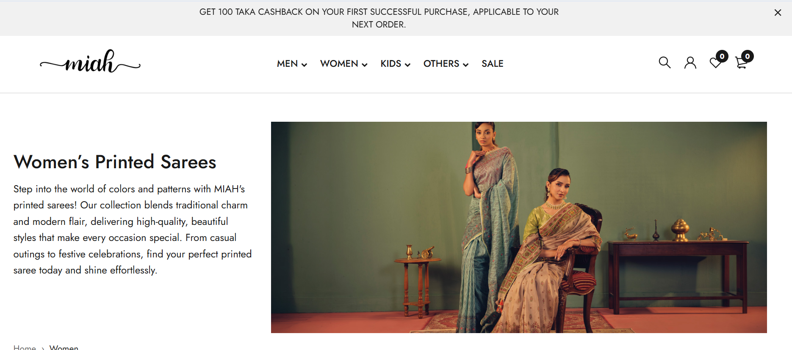

Figure-5: Product page view (Women)

🔹 Product Descriptions

Descriptions highlight key benefits like warmth, comfort, and trendy design.

Language is clear and persuasive for customers.

However, important details are missing:

Fabric composition

Care instructions

Additional product specifications

Adding these would improve clarity and customer trust.

🔹 Size Options and Pricing

Product price is clearly displayed and easy to understand.

At least one size (XL) is shown, but availability of other sizes is unclear.

No detailed size guide is provided.

Adding a full size chart in the initial view (S, M, L, XL with measurements) would reduce confusion and returns.

🔹 Reviews / Ratings

No visible customer reviews or ratings on the product page.

This reduces trust and affects purchase decisions.

Adding:

Star ratings

Customer reviews

User-uploaded photos
would significantly improve credibility.

🔹 Overall Observation

The product page is simple and informative in terms of pricing and description.

However, it lacks:

Strong visual presentation

Trust-building elements

Improving these areas would enhance user confidence and increase sales.

5. Cart & Checkout Experience
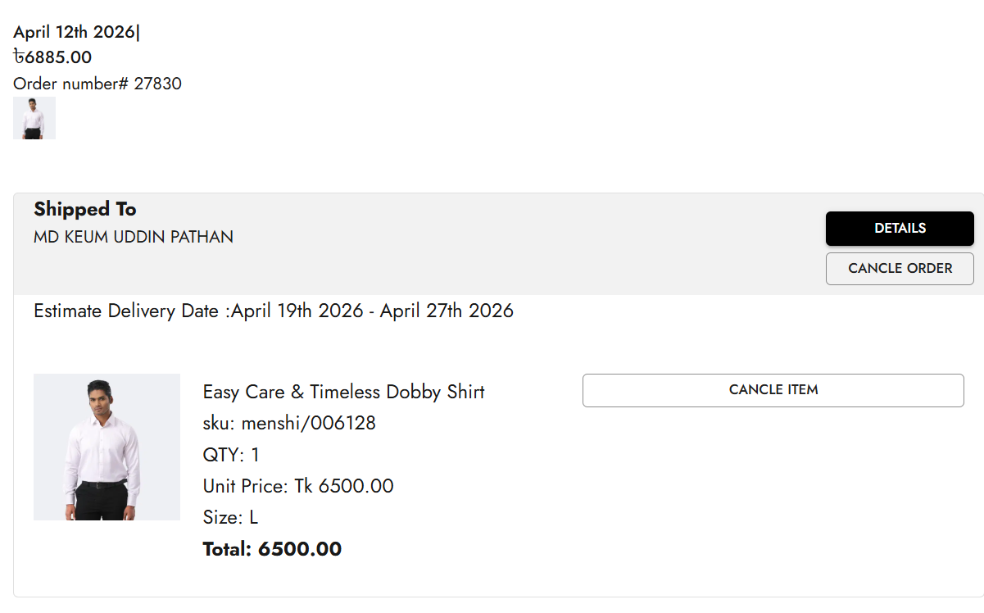
Figure-6: Miah Shop Checkout

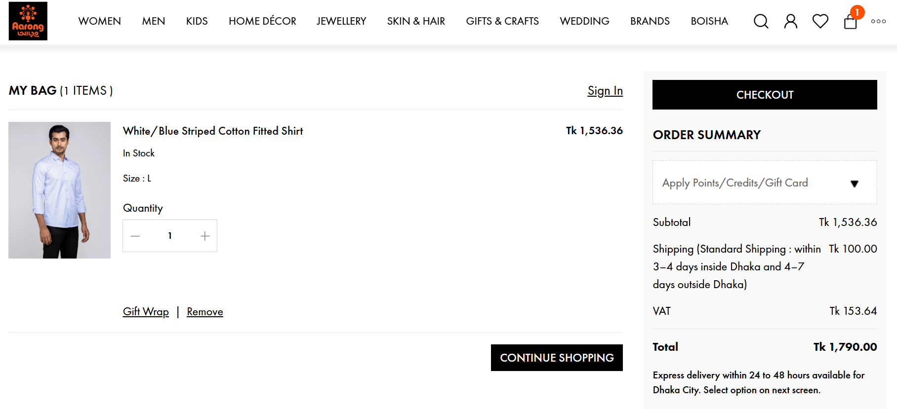
Figure-7: Aarong Checkout
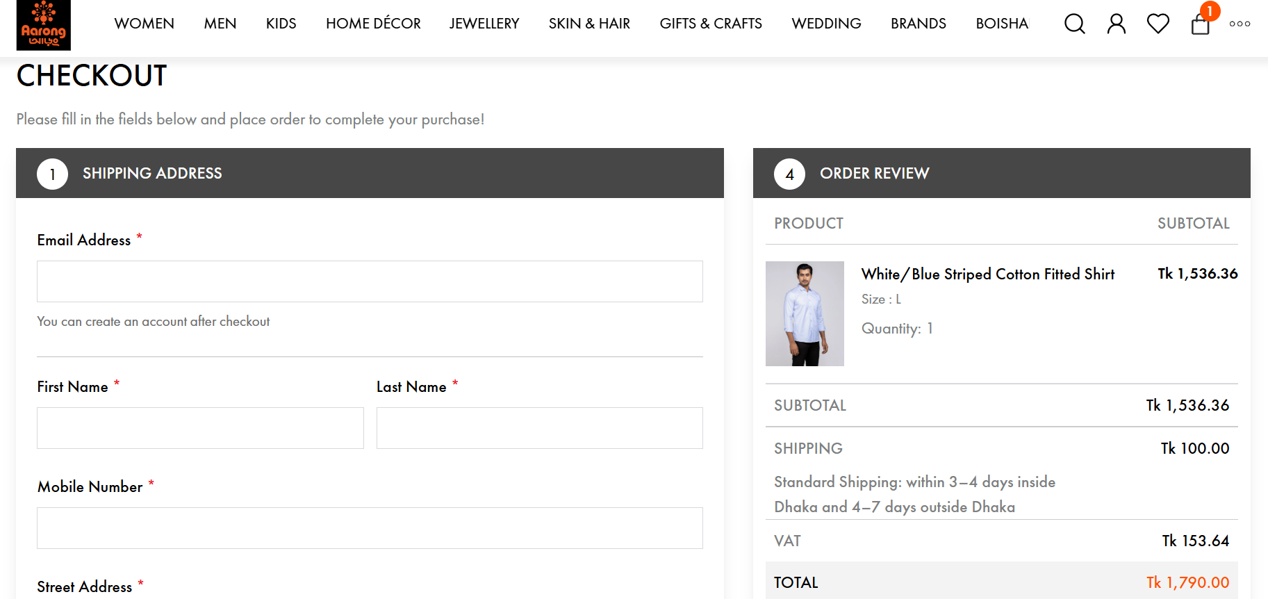
Figure-8: Aarong Checkout-1

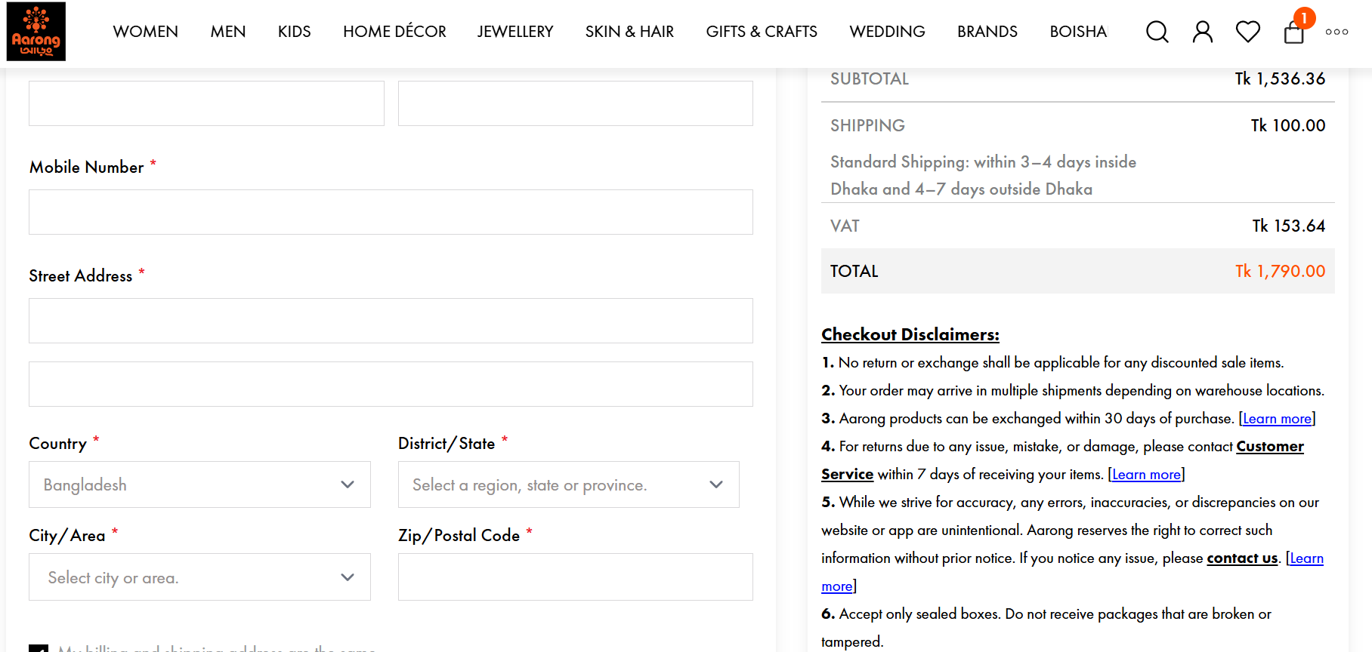

Delivery timeline not clearly shown
Problem: No clear “inside Dhaka / outside Dhaka / express vs standard” info
Impact: Users hesitate to purchase because delivery expectations are unclear
Recommendation:
- Show estimated delivery times before checkout and during checkout
- Example:
  - Inside Dhaka: 1–2 days
  - Outside Dhaka: 3–5 days
  - Express option (if available)

Order cancellation is hard to find
Problem: Users can’t easily cancel orders
Impact: Creates frustration + reduces trust
Recommendation:
- Add a clear “Cancel Order” button in:
  - Order confirmation page
  - User account → Order history
- Mention cancellation policy clearly (time window, refund process)

Payment options are not straightforward
Problem: Payment flow feels indirect or confusing
Impact: Major drop-off at checkout (this is where most users abandon)
Recommendation:
- Simplify and highlight:
  - Cash on Delivery (very important in Bangladesh)
  - Mobile payments like bKash, Nagad
  - Cards (if available)
- Show all options clearly on one screen (don’t hide behind steps)

Cannot change product quantity in checkout
Problem: Users must go back to cart to adjust quantity
Impact: Adds friction → increases abandonment
Recommendation:
- Add + / – buttons directly in checkout
- Update total price instantly

Priority (what to fix first)
- Payment flow clarity (highest impact on revenue)
- Delivery timeline visibility
- Checkout quantity editing
- Order cancellation UX
The current checkout experience has multiple friction points that can directly reduce conversions. Improving payment clarity, delivery transparency, and checkout flexibility will significantly enhance user trust and sales.

6. Mobile Experience
- Website takes more than 20 seconds to load in mobile

7. Content & Language
- Clarity of text (like cashback offers) should be visible and catchy
- Make the item descriptions short and simple

8. Suggestions for Improvement
Match each issue with a solution:
- Improve filter visibility
- Zoom in feature for each product
- Simplify promotional text with color and CTA button to get attention
- Add detailed size guide

